Task 1: Ethernet Cables vs. Fiber Optic Cables

Comparison Factor | Ethernet Cable (Twisted Pair Copper) | Fiber Optic Cable
Signal Transmission | Transmits data via electrical pulses over copper conductors. | Transmits data via light pulses through a core of ultra-pure glass or optical plastic.
Maximum Distance | Limited to 100 meters (328 feet) per segment before signal attenuation and packet loss occur. | Capable of long-distance transmission spanning several kilometers (up to 40 km+ with single-mode fiber) without repeaters.
Immunity to Interference | Ethernet cables are affected by electromagnetic interference (from power lines, motors, etc.) | Completely immune to EMI, RFI, and crosstalk because light carries no electrical charge.
Cost & Installation | Generally cheaper and easier to terminate using RJ45 connectors. | Generally, more expensive and requires specialized tools and handling.
Real-World Use Cases: | Connecting desktop PCs, gaming consoles, or access points directly to a local home Wi-Fi router or room switch over short distances. | A college campus or enterprise backbone linking separate multi-story buildings, or high-bandwidth interconnects in cloud data centers.

Task 2: Straight-Through Ethernet Cable Wiring (T568B Standard)

A straight-through cable uses the identical T568B wiring pinout on both End A and End B.
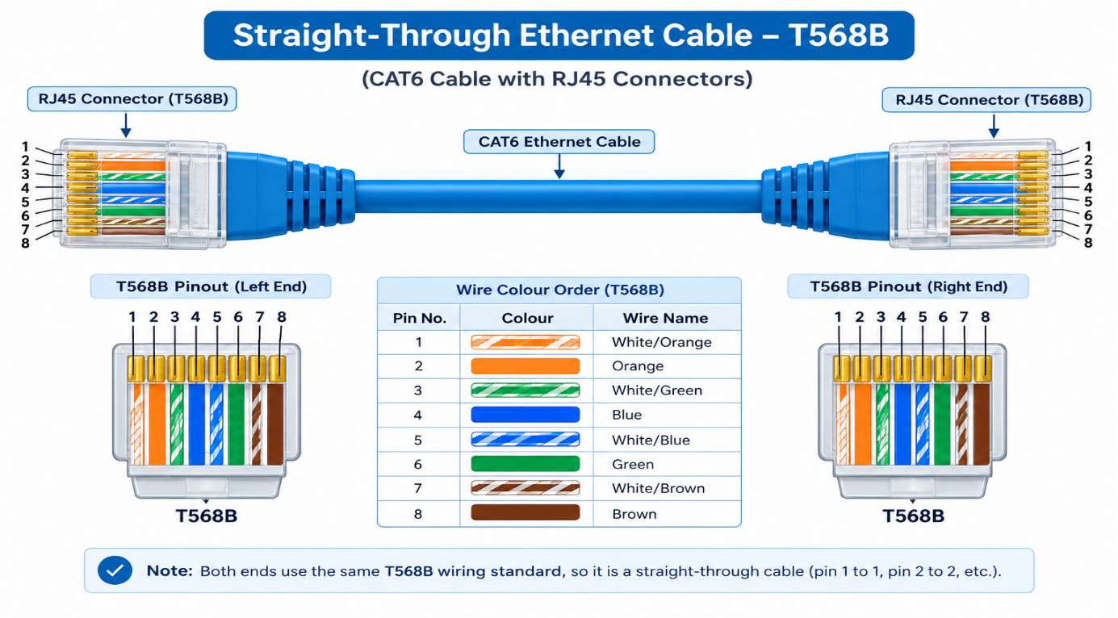
Task 3 — Attaching an RJ45 connector to a CAT6 cable (step-by-step)

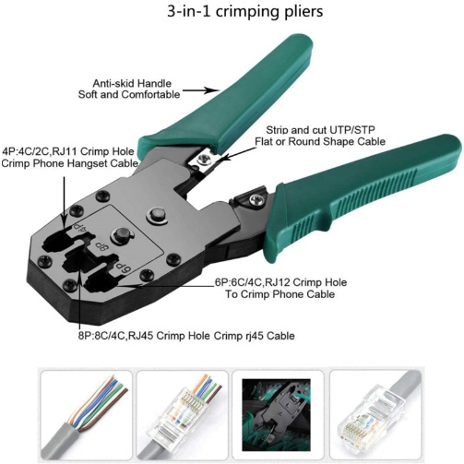
Required Tools
- CAT6 Ethernet cable
- RJ45 connectors
- RJ45 crimping tool
- Cable stripper/cutter
- Cable tester
Steps:
- Measure the cable: Cut the CAT6 cable to the required length.
- Strip the outer jacket: Use the stripper on the crimping tool to carefully remove a small section of the outer insulation.
- Separate the wires: Untwist and separate the four twisted pairs.
- Arrange the wires according to T568B
  - White/Orange
  - Orange
  - White/Green
  - Blue
  - White/Blue
  - Green
  - White/Brown
  - Brown
- Straighten the wires: Arrange the eight wires neatly in the correct order and trim their ends evenly.
- Insert the wires into the RJ45 connector: Push all eight wires fully into the connector while maintaining the T568B order.
- Check the arrangement: Look through the transparent connector and confirm that all eight wires reach the front contacts in the correct order.
- Crimp the connector: Place the RJ45 plug into the crimping tool and squeeze firmly to secure the contacts and cable jacket.
- Repeat for the other end: For a straight-through cable, use the same T568B order on the second end.
- Test the cable: Connect both ends to a cable tester and verify that pins 1–8 are correctly connected.

Task 4: Gaming Café Cable & Tool Selection

For a gaming café with 10 PCs, I would use CAT6 Ethernet cable rather than fiber optic cable for the connections between the gaming PCs and the switch. CAT6 provides sufficient speed and low latency for LAN gaming and is generally cheaper and easier to install for short distances. I would use an RJ45 crimping tool to terminate the CAT6 cables with RJ45 connectors. Fiber optic would be more appropriate for long-distance backbone connections where higher bandwidth and longer cable runs are required.

